SQL ASSIGNMENT 2

* Created a database named COMPANY.
* Within this database created a table named EMPLOYEES.
* Then inserted values into each row.

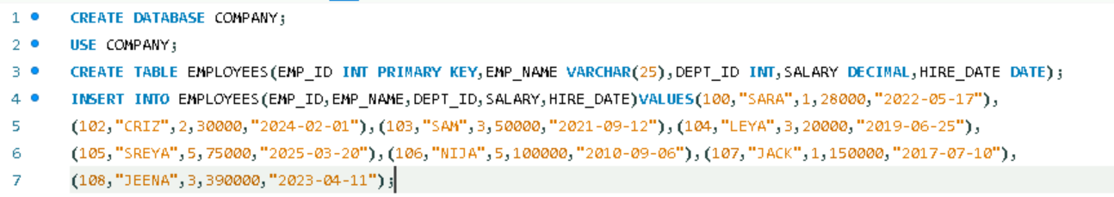

Part A: Data Retrieval (Basic SELECT)

1.Write a query to display all employees in the table.

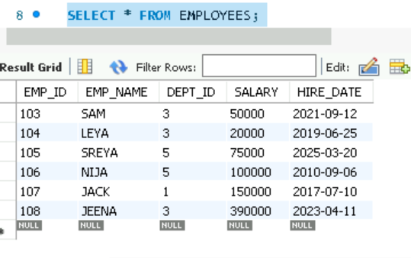

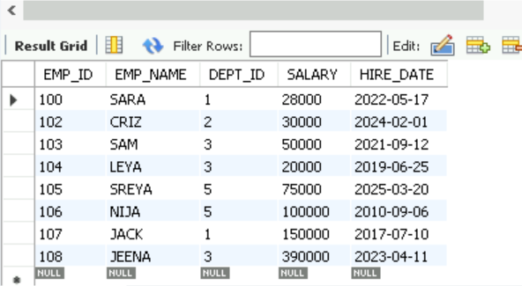

2.Show the names of employees who earn more than 50,000.

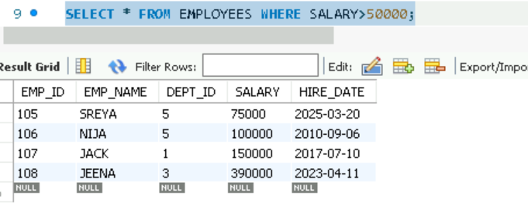

3.Retrieve the list of unique department IDs from the employees table.

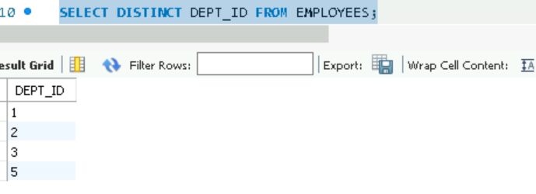

4.Display employee names and salaries sorted by salary descending.

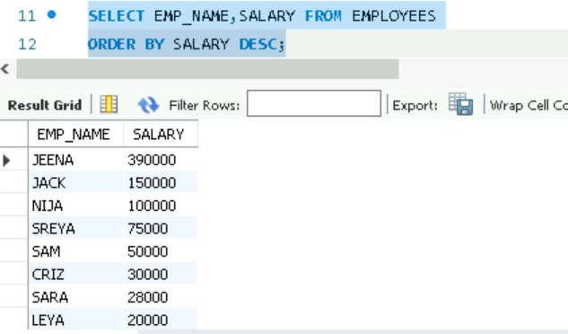

5.Find all employees hired after January 1,2020.

PART B: Filtering & Pattern Matching

6.Find employees whose name start with ‘J’.

7.Get all employees with salary between 40000 and 60000.

8.Show employees who do not belong to department ID 2.

PART C: Aggregations

9.Find the total number of employees in the company.

10.Show the average salary in each department.

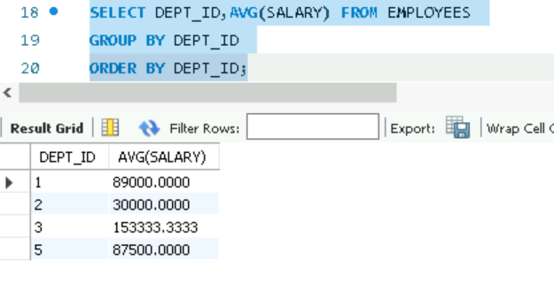

11.Find the highest salary in the employees table.

12.Count how many employees were hired in each year.

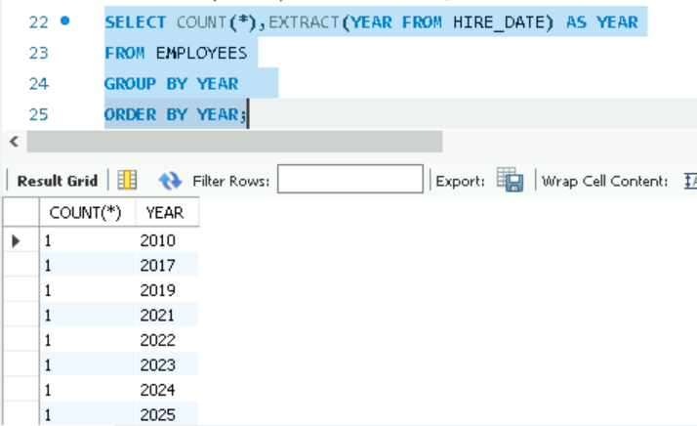

* Created a table named DEPARTMENTS.
* Added values into the table.

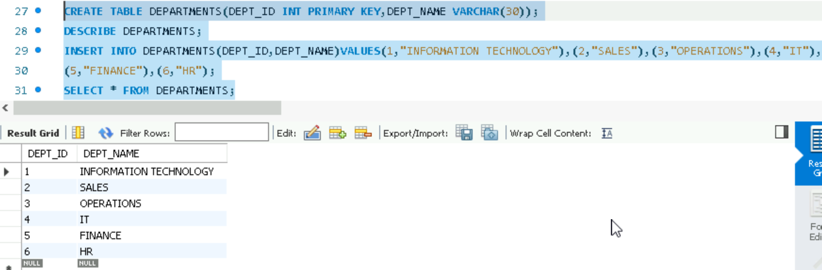

PART D: Joins

13.Write a query to display employee names along with their department names.

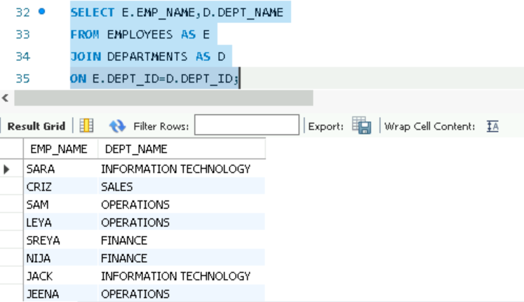

14.Find all employees working in the ‘Sales’ department.

15. List departments with no employees.

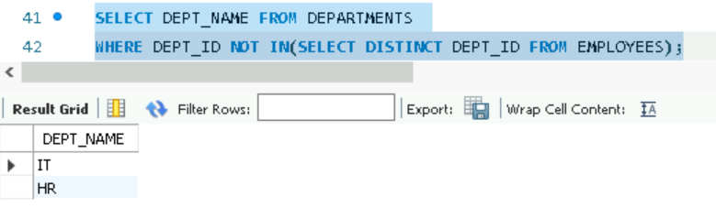

PART E: Subqueries

16.Find the name(s) of employee(s) with the highest salary.

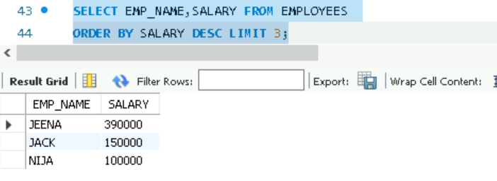

17.List the employees whose salary is above the average salary of all employees.

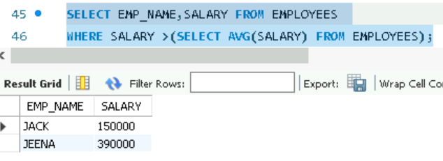

18.Show employees who earn more than the maximum salary in department ID 1.

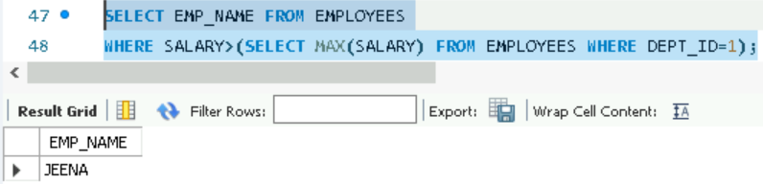

PART F: DML(Data Manipulation)

19.Update the salary by 10% for employees in the ‘HR’ department.

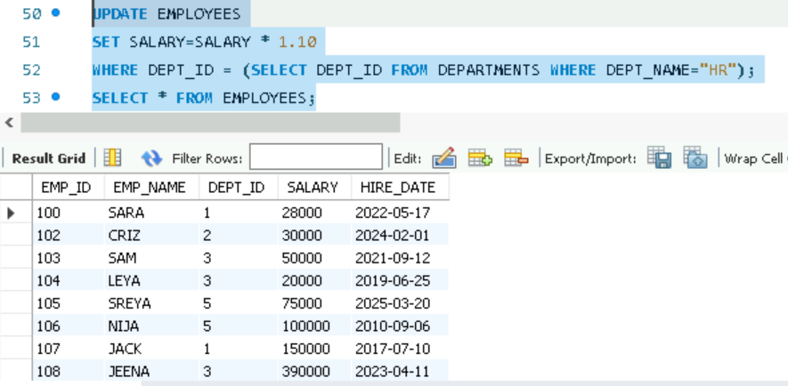

20.Delete employees who have a salary less than 30,000.

